WYNGATE JANUARY DINE OUT
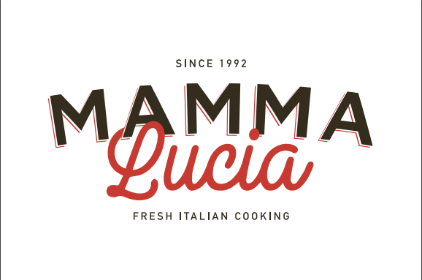

January 23, 2020
5 p.m. Until Close

Dine in or carry out and help Wyngate Elementary School!
Bring this flyer with you and Wyngate will get 20% of the sales from the evening!

Mama Lucia --Bethesda
www.mammaluciarestaurants.com
4916 Elm St, Bethesda, MD 20814
(301) 907-3399

