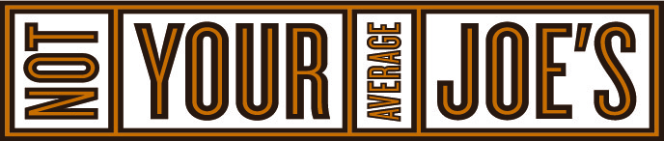

**We serve creative cuisine. And worthy causes.**

**WYNGATE PTA**

**“Present this flyer to your server and WYNGATE PTA will receive 15% of your total purchase.”**



**POSI: CAUSE # 2**

**VALID DECEMBER 11, 2019**

**Not Your Average Joes**

**10400 OLD GEORGETOWN ROAD**

**BETHESDA, MD 20814**

**240.316.4555**

*Excludes Alcohol, Tax and Gratuity

