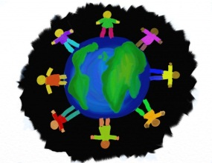
WYNGATE MULTICULTURAL NIGHT (2015-16)
Thursday, October 15
6.30 pm - 8:30 pm

You are invited to celebrate Wyngate’s international and multicultural community with us! Last April families showcased Argentina, Bangladesh, Brazil, China, Colombia, Denmark, El Salvador, France, Japan, Iceland, India, Indonesia, Iran, Nicaragua, Russia, Scotland, Spain, Saudi Arabia, South Korea, Turkey, Trinidad, Uruguay, Venezuela, and Wales.

If you can represent a country or a culture, please consider hosting a table for this fun and vibrant evening. This is a great event for girl or boy scout troop projects. Grandparents, and other family members, are welcome to participate.

- DECORATE A TABLE TO SHOWCASE YOUR COUNTRY/CULTURE - art, textiles/cloth, carvings, instruments, money, stamps, books, children’s games, flags, pictures...; share finger food “specialties” from your country; wear traditional costumes or clothing.
- CULTURAL ENTERTAINMENT- children can sing, dance, play traditional music, read a poem from their country. On this night, Wyngate brings the world to OUR stage!
To reserve a table, email Alison at a_corbett@comcast.net – indicate how many tables/chairs you need, if you require an electrical outlet, or have any other special requests.
To schedule a performance, email Sandra: sandraali@me.com – describe the performance and approximately how long it will last.

DEADLINE TO RESPOND: FRIDAY OCTOBER 9TH

